Hello

This is Yaseen attempting to add this file to github through new work laptop(23/11/2016).

This line should make it reflect as been modified after the file has been added. As shown below

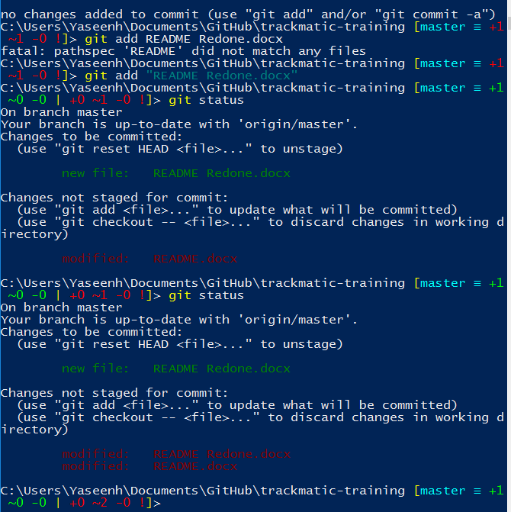

Using the log shows you changes made

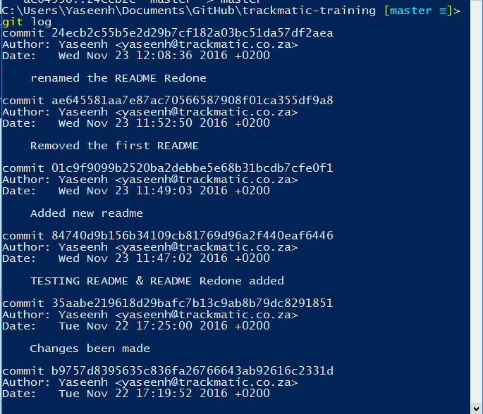

This line indicates the use of me amending

For upstaging one of two files